How to Dendrograms Work?

We created clusters and kept on clustering till we got a single cluster. So, what was the purpose of doing so? And how do we find the right number of clusters?

Here we have got a chart with 6 points and a user’s chart to create a dendrogram

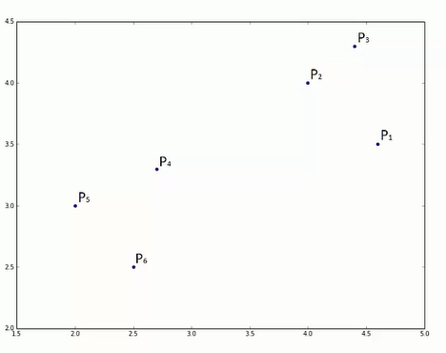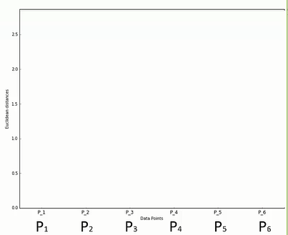

by following step 1 we get p2 and p3 as the closest points.

Now somehow on the dendrogram we have to signify that these were the closest points( because dendrogram is a kind of memory of hierarchical clustering. It is going to remember every single step that we areareforming.)

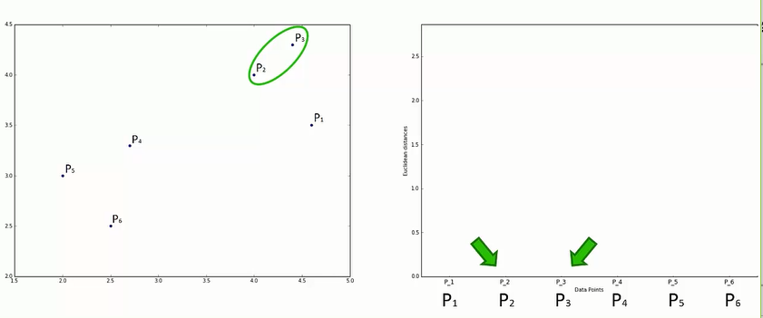

How do we signify that these two points are closest?

-> Connect them using a horizontal line.

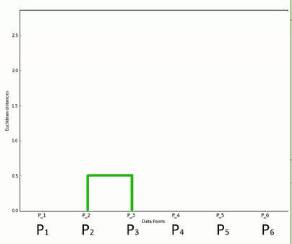

Height is equal to the

euclidean distance between

them

(distance between them

also indicates dissimilarities

between them. )

